Full Stack Programming Lab
BSSE-VI-B & A
Lab_05
Frontend React JS
Instructor:
Mr. Sharif Hussain

Lab Title: Frontend JavaScript Library Reactjs
Contents
1. MERN Stack 3
2. Your system needs a runtime environment: 3
3. Step 2: Create React Project 4
4. Step 3: Open Project Folder and run React Application 4
Step 5: Understand Project Structure 5
Important Files 5
Step 6: Edit First React Code 6
5. React Components 6
6. React PROPS 8
Lab Task Instructions: 9
Lab Tasks: - 10

Lab Objectives
After completing this lab, students will be able to:
- Understand what React is
- Install React environment
- Create a React project
- Run the React development server
- Understand project structure
- Display first React output
Software Requirements
- Node.js
- Visual Studio Code
- Web Browser

MERN Stack
MERN Stack is a collection of powerful technologies and robust, used to develop scalable master web applications comprising backend, front-end, and database components.
- MongoDB: A NoSQL database for data storage.
- Express.js: A backend framework for handling HTTP requests and business logic.
- React: A front-end library for building user interfaces.
  - Also, use Next JS in coming days.
- Node.js: The server-side runtime for executing JavaScript code.

Your system needs a runtime environment:
What is Node.js?
- Node.js is an open-source server environment/ runtime environment for JavaScript
- Node.js runs on various platforms (Windows, Linux, Unix, Mac OS X, etc.)
- Node.js uses JavaScript on the server (JavaScript everywhere)
- Used to build backend services/ Web APIs
Install Node.js
Go to https://nodejs.org/en/download and download the LTS (Long Term Support) version of Node.js. It includes npm (Node Package Manager), which is required to install React and other JavaScript packages.
Verify installation:
Open your terminal (Command Prompt, PowerShell, or Terminal on Mac) and type:
- node –v
- npm –v
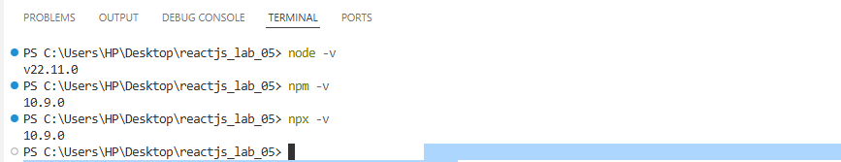

Step 2: Create React Project
Run the following command:
npx create-react-app my-first-react-app

npx: Runs Node packages
create-react-app: Tool to create React project
my-first-react-app: Project name

Step 3: Open Project Folder and run React Application

Move into the project directory:
cd my-first-react-app

Run React Application
npm start

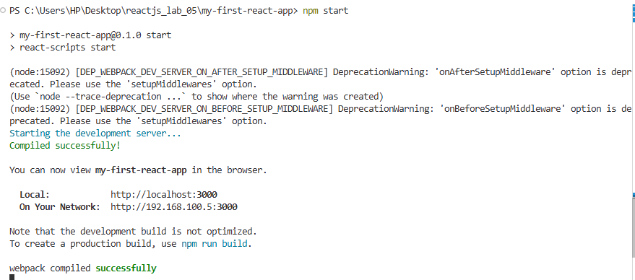

Default app UI:

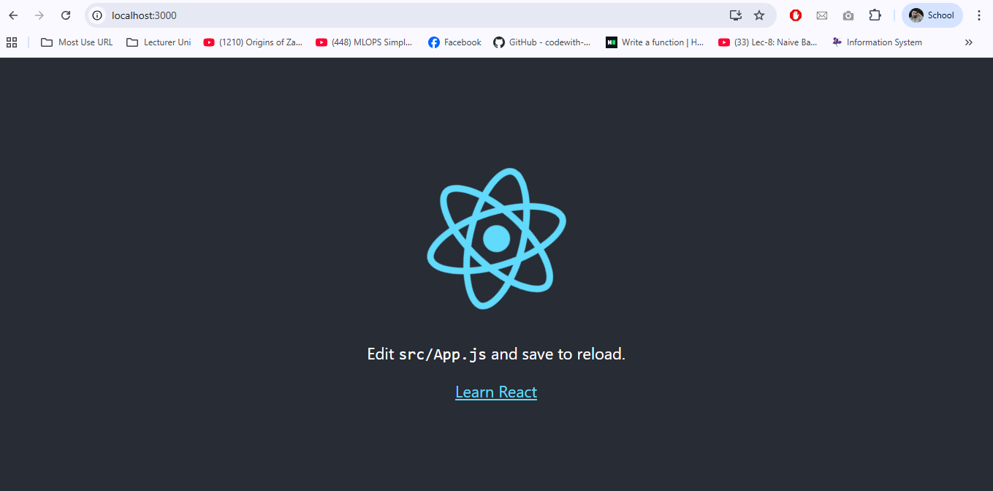

Step 5: Understand Project Structure

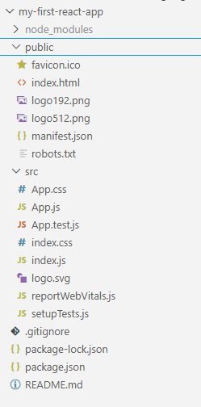

Important Files
File | Purpose
index.js | Entry point of React
App.js | Main component
App.css | Styling
package.json | Project dependencies

Step 6: Edit First React Code
Open src/App.js file and you can edit this for Simple JSX Rendering:
import './App.css';
function App() {
return (
<div>
<h1>Hello Students </h1>
<h2>Welcome to React JS Lab</h2>
<p>This is my first React application.</p>
</div>
);
}
export default App;

React Components
A React component is a reusable piece of code responsible for rendering a part of the user interface. These components can be as simple as a button or as complex as an entire form.
Example components:
- Navbar
- Footer
- Login Form
- Product Card
Two Types of Components in React
- Functional Components
A Functional Component is a simple JavaScript function that returns JSX.
It is the most commonly used type in modern React because it is simpler and shorter.
import './App.css';
function Welcome() {
return <h1>Hello Students</h1>;
}
function App() {
return (
<div>
<Welcome />
</div>
);
}
export default App;
- Class Components
A Class Component is created using JavaScript classes.
Earlier versions of React used class components to manage state and lifecycle methods.
import './App.css';
import React, { Component } from "react";
class Welcome extends Component {
render() {
return <h1>Hello Students</h1>;
}
}
function App() {
return (
<div>
<Welcome />
</div>
);
}
export default App;

React PROPS
In React, Props (short for “properties”) are used to pass data from a Parent component to a Child component.
You can think of props like:
- Arguments in a JavaScript function
- Attributes in an HTML tag
Props make components dynamic and reusable, so you don’t have to hard-code the same content every time.
Key Points about Props
- Read-Only:
A child component can access props, but cannot change them.
- Uni-directional:
Data flows one way — from the Parent down to the Child component.

Example:
import './App.css';
function Student(props) {
return (
<div>
<h2>Name: {props.name}</h2>
<p>Department: {props.department}</p>
<p>University: {props.university}</p>
</div>
);
}
function App() {
return (
<div>
<Student name="Ali" department="Software Engineering" university="Air University" />
<Student name="Musharaf" department="AI & ML" university="Air University" />
</div>
);
}
export default App;

Lab Task Instructions:
- Create a GitHub account if you don’t have one.
- Create a repository named: Full-stack-programming-lab.
- Add me as a collaborator: email: - sharifali.aulecturer@gmail.com.
- Clone the repository to your local machine.
- Inside the repository, create a new folder Lab_05_reactjsApp.
- Complete all lab tasks assigned in this folder using HTML, CSS, and JavaScript.
- Push your completed work back to GitHub.
- Make a Word or PDF file and add your screenshots as you know better:
  - Include screenshots of outputs
  - Add your GitHub repository URL
  - Upload the Word/PDF file to GCR for submission

Lab Tasks: -
- Lab Task 1: Student Information Card App Objective: Practice creating components and props.
Instructions:-
- Create a React app ‘student-card-app’.
- Create ‘StudentCard’ component with props: name, rollNo, department, university.
- Display 3 students using the same component.
Bonus: Add ‘color’ prop to change card background.

- Lab Task 2: Course List App Objective: Render lists using props.
Instructions:-
- Create ‘course-list-app’.
- Create ‘CourseItem’ component with props: courseName, instructor, duration.
- Use an array of 5 courses and map to render CourseItem components.
Bonus: Add course type prop (Online/Offline) and display it.

- Lab Task 3: Dynamic Greeting App Objective: Use props with simple conditional rendering.
Instructions:-
- Create ‘greeting-app’.
- Create ‘Greeting’ component with props: name, timeOfDay.
- Display greetings based on timeOfDay. 4. Render at least 3 Greeting components with different props.
Bonus: Add ‘bgColor’ prop to set background color.

✨🌟 Best of Luck 🌟✨

